P13L assay – T. Graber December 7 .2021

Backgrounder on apparoach used: https://www.sciencedirect.com/science/article/pii/S0043135421008769?via%3Dihub

Note this mutation is also prevalent in Lambda VOC in addition to Omicron.



The probe and primer design are pictured with Wuhan coordinates. Sequences are:

>C28311.for

CCAAAATCAGCGAAATGaACC

>C28311T.for

CCAAAATCAGCGAAATGaACt

2019-nCoV_N1_Reverse

>TCTGGTTACTGCCAGTTGAATCTG

>N1v2_probe

FAM-CCGCATTACGTTTGGTGGACCC-MGBNFQ

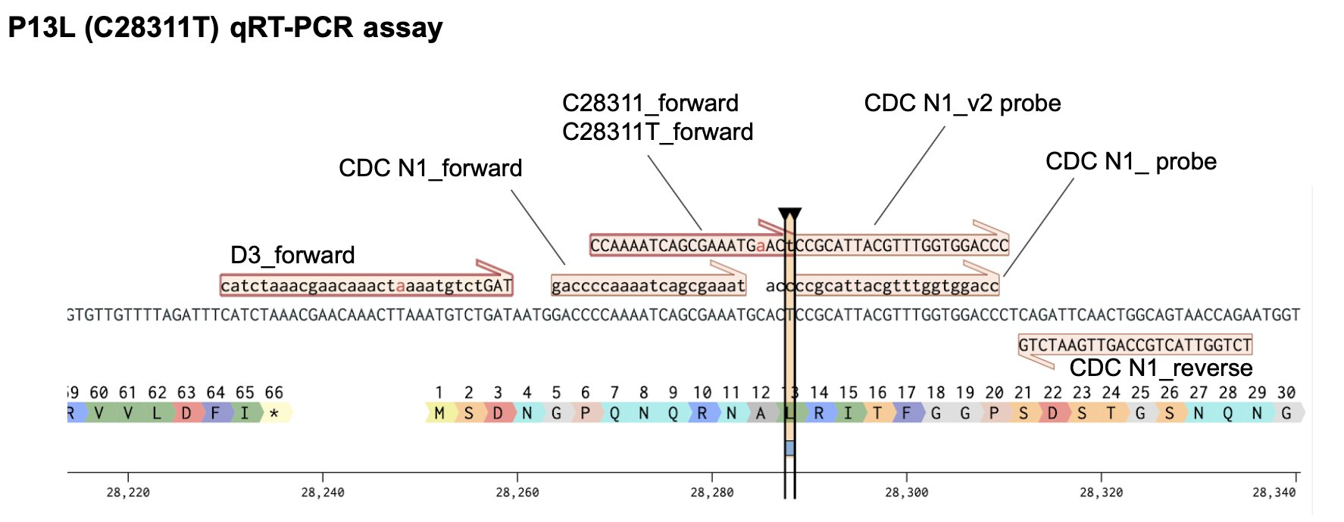

C28311T assay doesn’t amplify on orthologous C28311 template (i.e. Delta). C28311 assay on C28311 template is comparable to existing N1 assay. Slightly higher y-intercept for C28311T assay on C28311T template (i.e, Omicron/Lambda).

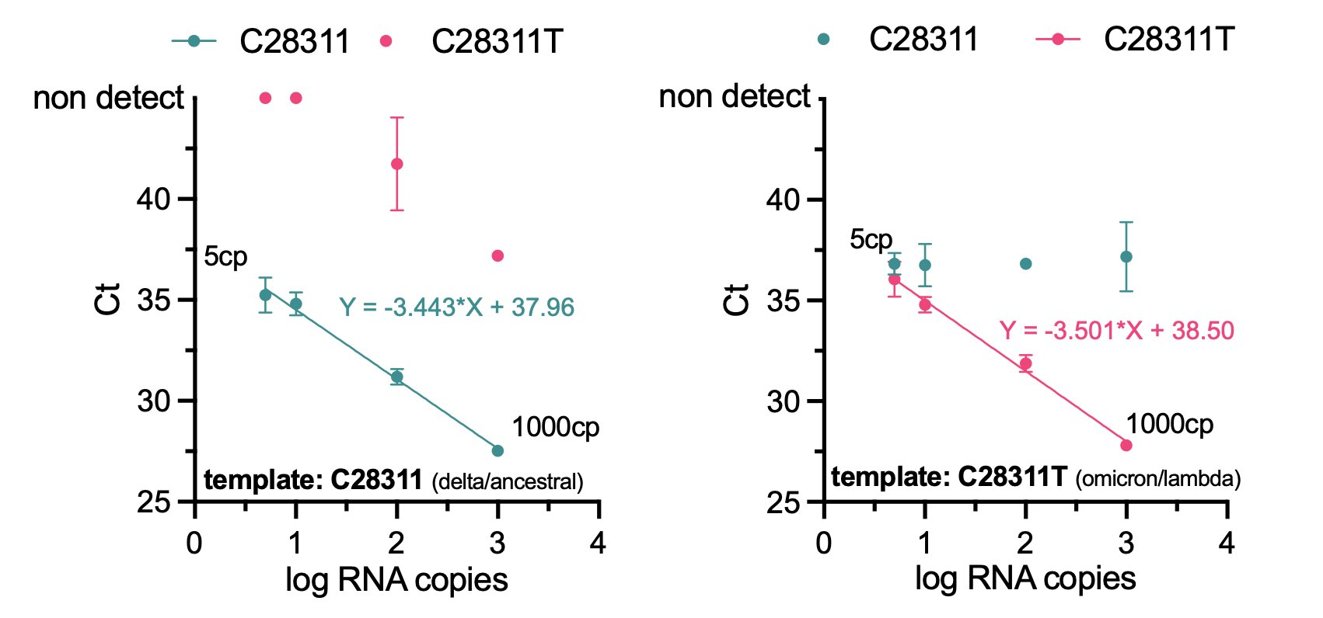

Wastewater:

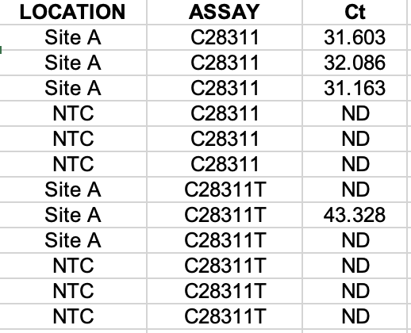

Reaction conditons:

